**Data model Assignment on AdventureWorks**

**Database**: AdventureWorksDW2014 – “reseller sales”

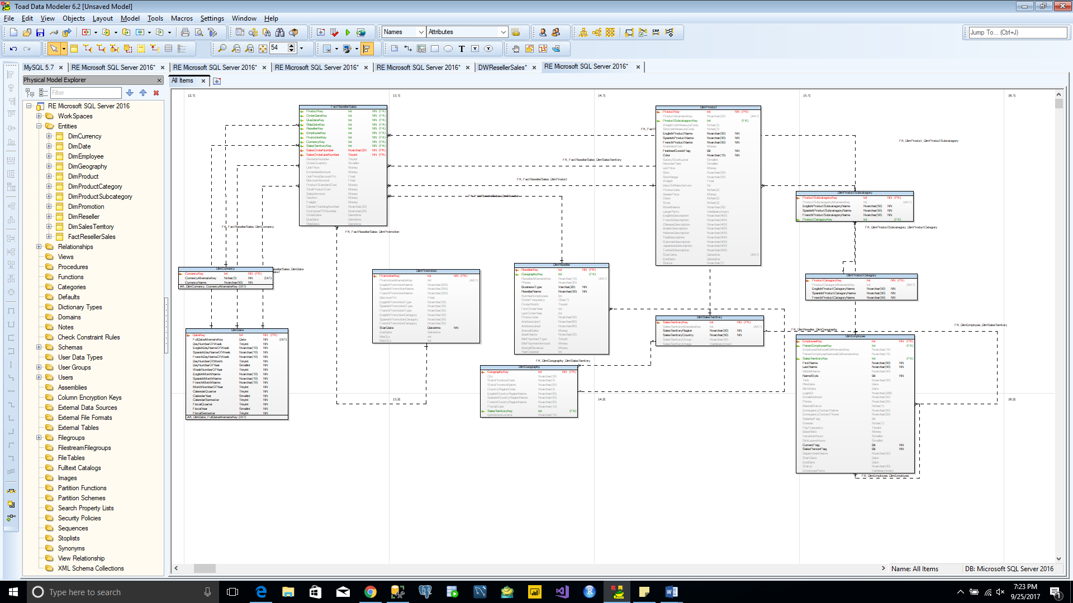

|  |  |  |
| --- | --- | --- |
| **SL.No** | **Table Names** | **Types** |
| 1 | FactResellerSales | Fact |
| 2 | DimDate | Dimension |
| 3 | DimReseller | Dimension |
| 4 | DimCurrency | Dimension |
| 5 | DimSalesTerritory | Dimension |
| 6 | DimPromotion | Dimension |
| 7 | DimEmployee | Dimension |
| 8 | DimProduct | Dimension |
| 9 | DimProductSubCategory | Dimension |
| 10 | DimProductSubCategory | Dimension |
| 11 | DimGeography | Dimension |

**Database**: AdventureWorksDW2014 – “internet sales”

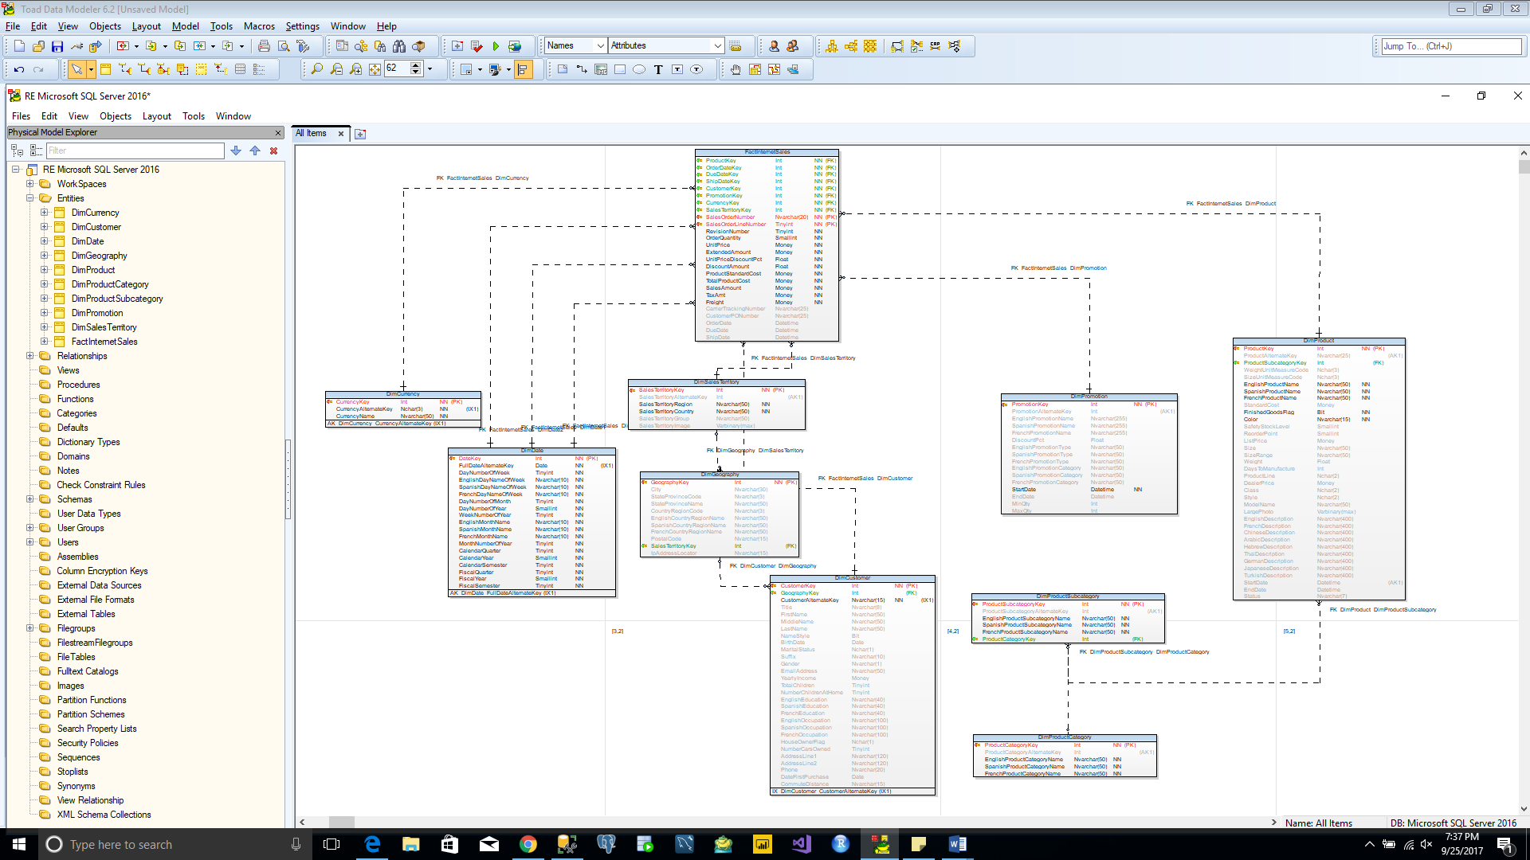

|  |  |  |
| --- | --- | --- |
| **SL.No** | **Table Names** | **Types** |
| 1 | FactInternetSales | Fact |
| 2 | DimDate | Dimension |
| 3 | DimPromotion | Dimension |
| 4 | DimCurrency | Dimension |
| 5 | DimSalesTerritory | Dimension |
| 6 | DimCustomer | Dimension |
| 7 | DimProduct | Dimension |
| 8 | DimProductSubCategory | Dimension |
| 9 | DimProductSubCategory | Dimension |
| 10 | DimGeography | Dimension |

**Database**: AdventureWorks2014 – “sales”

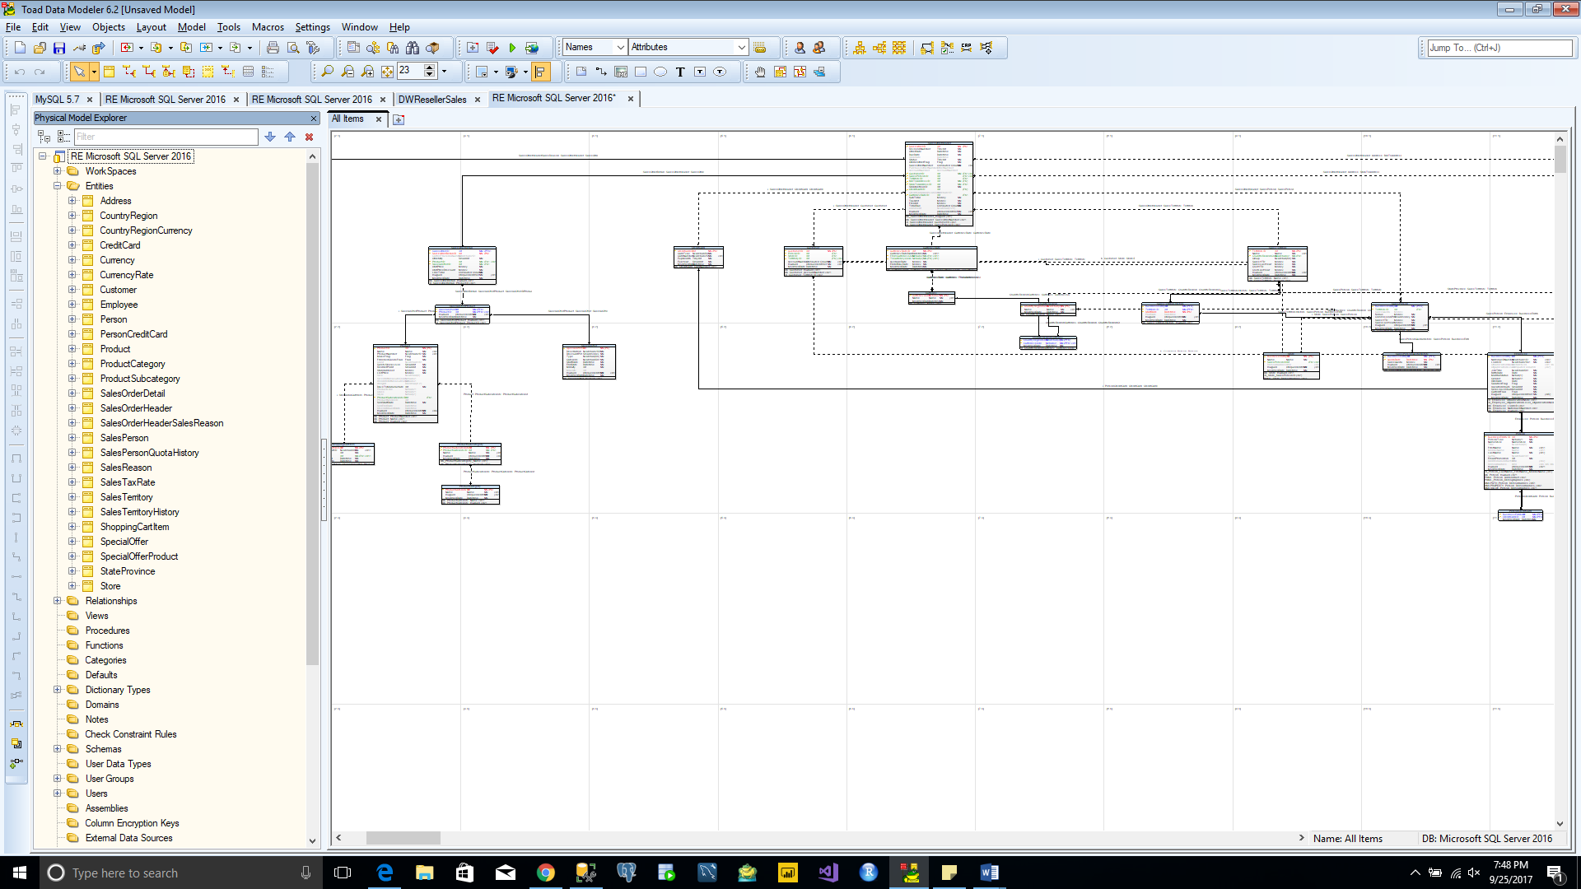

|  |  |  |
| --- | --- | --- |
| **SL.No** | **Table Names** | **Schema Type** |
| 1 | ShoppingCartItem | Fact |
| 2 | SpecialOffer | Sales |
| 3 | SpecialOfferProduct | Sales |
| 4 | Store | Sales |
| 5 | CountryRegionCurrency | Sales |
| 6 | CreditCard | Sales |
| 7 | Currency | Sales |
| 8 | CurrencyRate | Sales |
| 9 | Customer | Sales |
| 10 | SalesOrderDetail | Sales |
| 11 | SalesOrderHeader | Sales |
| 12 | SalesOrderHeaderSalesReason | Sales |
| 13 | SalesPerson | Sales |
| 14 | SalesPersonQuotaHistory | Sales |
| 15 | SalesReason | Sales |
| 16 | SalesTaxRate | Sales |
| 17 | PersonCreditCard | Sales |
| 18 | SalesTerritory | Sales |
| 19 | SalesTerritoryHistory | Sales |
| 20 | Address | Person |
| 21 | StateProvince | Person |
| 22 | CountryRegion | Person |
| 23 | Person | Person |
| 24 | Product | Production |
| 25 | ProductSubCategory | Production |
| 26 | ProductCategory | Production |
| 27 | Employee | HumanRecourse |